**OLTP(Online Transactional Processing System):**

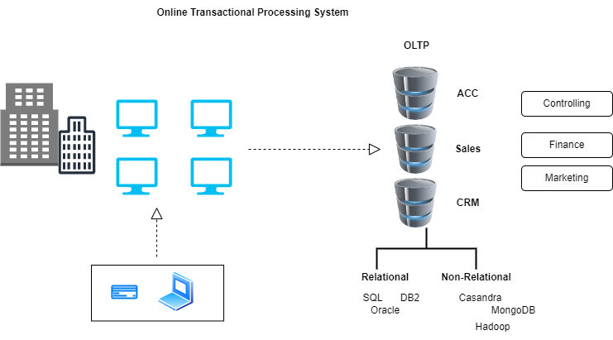

In OLTP system, separately owned by different department, and they do not share their data. They have to manually query to build report.

* Minimizing Locking
* Fast data insert and update
* Not suitable for reporting
* Simple queries

**Data Warehouse:**

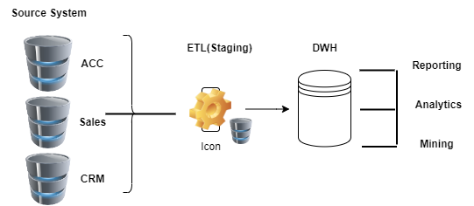

* More accessible for end-user
* Make strategic decision
* Store historic data
* Single point of truth
* Higher data quality and data integrity
* Faster decision

**Data Warehouse Architecture:**

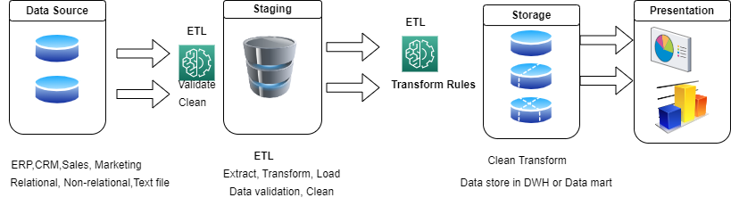

**Staging:**

* Intermediate storage area during ETL operation.
* Hold the data in temporary table
* 1 to 1 copies of tables from the source system

**Data Mart:**

* Smallest subset of Data
* One subject area
* Easier maintenance

**OLT VS DWH:**

|  |  |
| --- | --- |
| **OLTP** | **DWH** |
| Performance is about insert and update quickly | Performance is about reading data quickly |
| Locking must be minimize | Locking is not an issue |
| Small set of data retrieved in a query | Large set of data retrieved in a query |
| Normalized data model | De-normalized data model |
| Based on current data | Based on Historical data |
| Used by employee on front-line like clerk, cashier to record and review transaction | Used by knowledge worker like analyst |
|  |  |

**Data Normalization:**

Normalization is the process which divides larger tables into smaller table to minimize data **redundancy.**

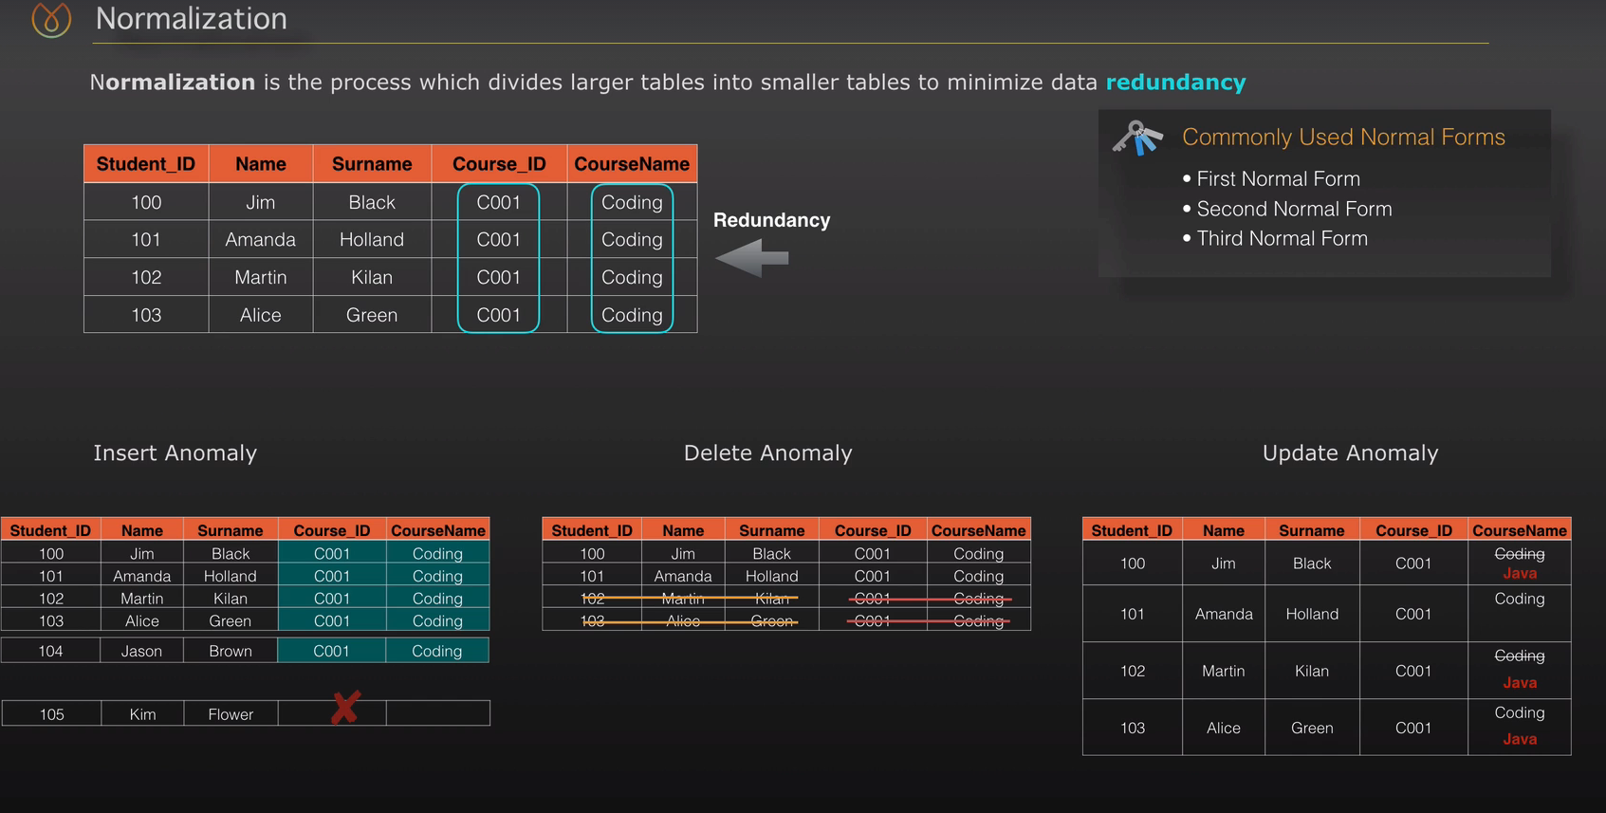

**Insert Anomaly:**

If we want to insert student data, and expecting to enroll to course later, it is not possible.

**Delete Anomaly:**

If we want to delete student, then course data also be delete.

**Update Anomaly:**

Unable to change update course data

**1 NF:**

* Column cell cannot hold multiple values

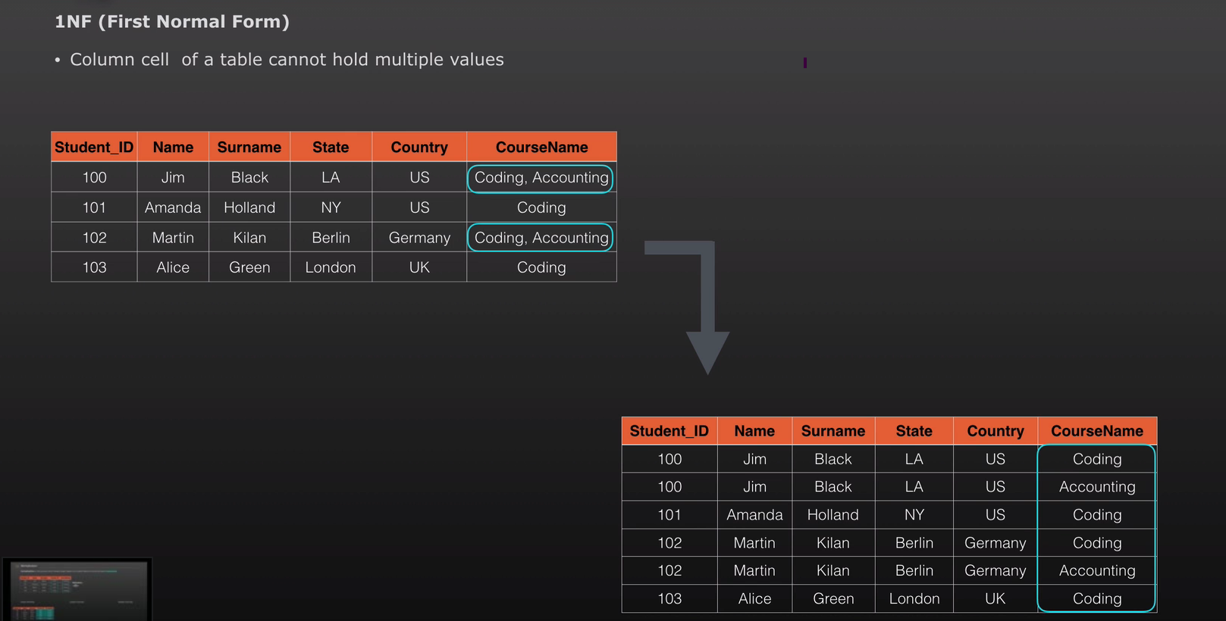

Multiple values have inserted into separate column but it has data redundancy, therefore **2NF** come into picture

**2NF:**

* Achieved the first normal form
* Redundant data across the multiple rows must be moved to separate table.

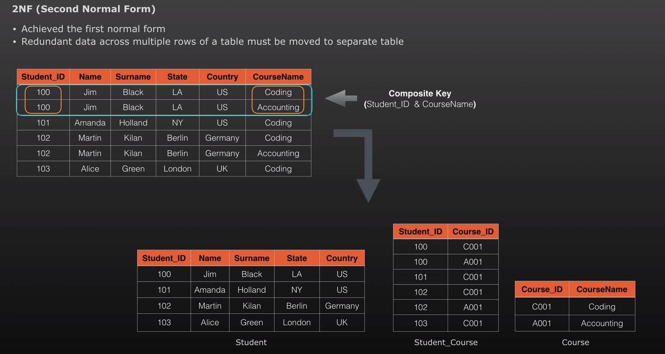

Here, first table containing duplicate rows, so in order to make **2NF,** student info are kept in student table, courses are kept in course table and ,created relation table for student and course. Here redundant data removed. But still country is repeated. Therefore, 3NF come into picture

**3NF:**

* Achieved the second normal form
* Eliminate the field that do not depend of Primary key.

In below 2NF table , we can see that **country** and **state** are not dependent on primary key, but **state** is dependent on **country,** therefore, move country data into separate table

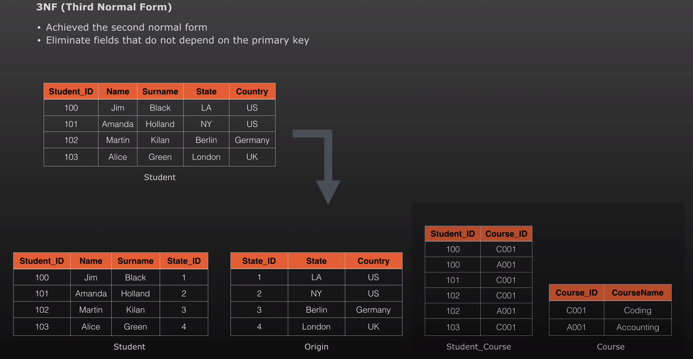

**Demoralization:**

**Demoralization**  is the process where data from multiple tables are combined into one table, so the data retrieval will be faster. It does not mean to avoid normalization. It is an optimization technique that apply after doing normalization.

**Normalization VS Demoralization:**

|  |  |  |
| --- | --- | --- |
|  | **Normalization** | **Demoralization** |
| **Implementation** | Divides large table into smaller tables reduce redundancy | Combine table into large table create redundancy |
| **Number of Table** | Increase Number of table hence join | Decrease Number of table hence join |
| **Query Execution** | Update, delete and write operation is higher | Speed of read operation is higher hence faster execution of the query |
| **Used In** | OLTP system, emphasize fast write operation | OLAP system, emphasize fast read operation |
| **Memory Consumption** | Memory consumption is less due to less redundancy | Memory consumption is more due to redundancy |
|  |  |  |
|  |  |  |

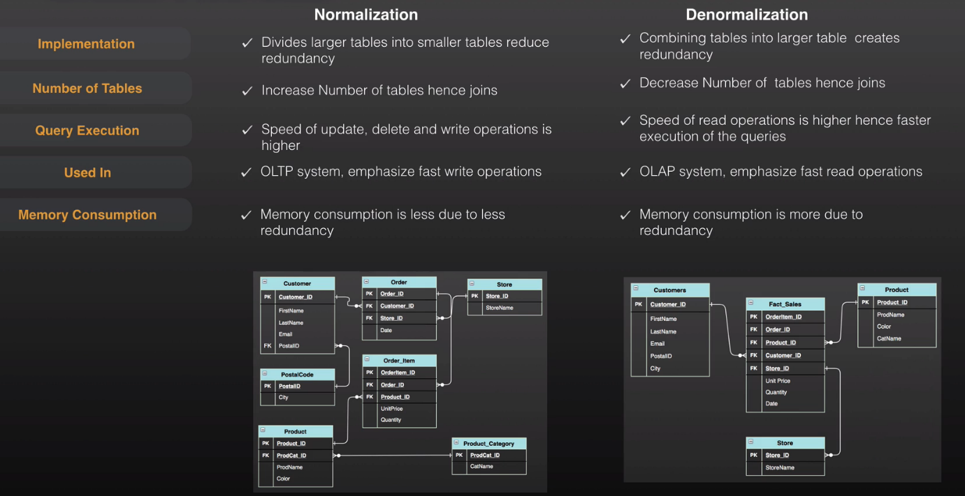

**Data Warehouse design Approach:**

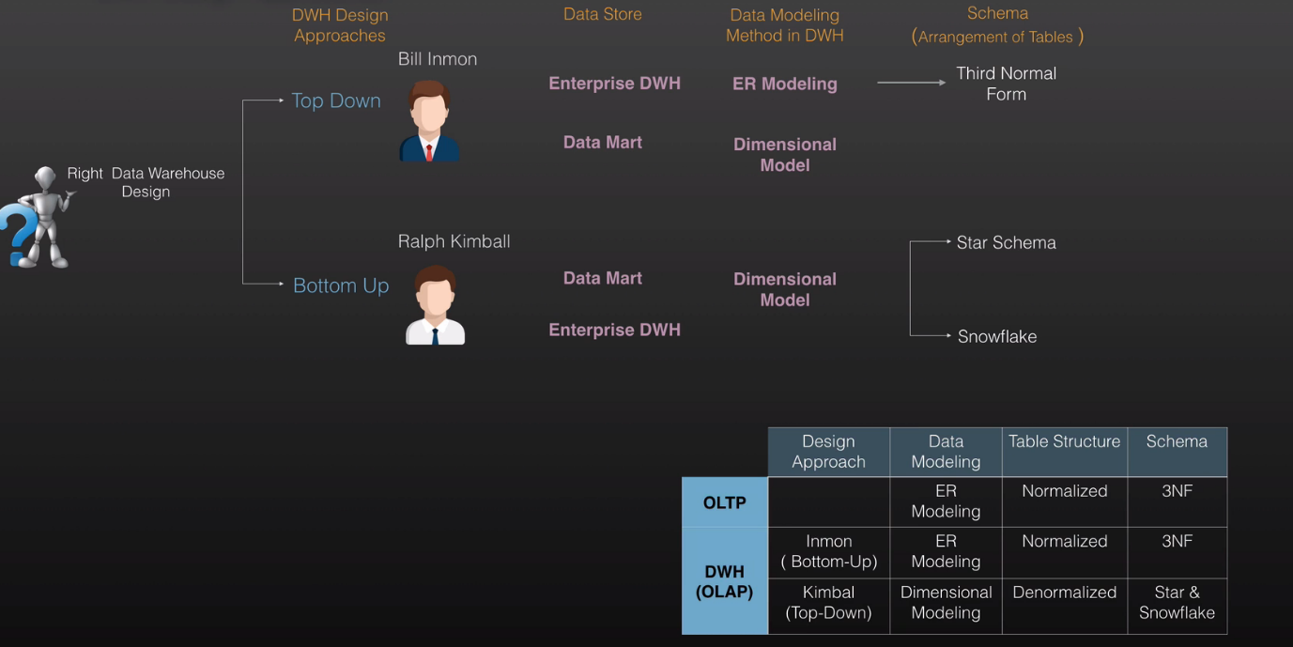

**Common Terminology in Data Modeling.**

|  |  |  |  |  |
| --- | --- | --- | --- | --- |
|  | **Design Approach** | **Data Modeling** | **Table Structure** | **Schema** |
| **OLTP** |  | ER Modeling | Normalized | 3NF |
| **DWH(OLAP)** | Inmon(Bottom Up) | ER Modeling | Normalized | 3NF |
| KimBal(Top Down) | Dimensional Modeling | Denormalized | Star & Snowflake |

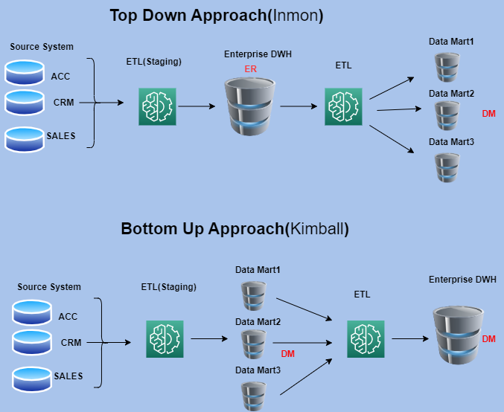

**Top Down Approach:**

* Emphasize enterprise DWH
* DW has atomic level data
* Data Marts have summary
* The DW ER-based normalized model.
* The data marts are subject specific dimensional model.

**Advantages:**

* Single point of truth.
* Flexible Enterprise changes
* Subsequent project cost is lower

**Drawbacks:**

* Inflexible to changing departmental needs quickly
* The model become complex over time
* The initial set-up delivery will take more time

**Bottom Up Approach:**

* Emphasize Data Marts
* DM based on deformalized dimensions model
* DM contain both atomic and summary data.
* DM integrated using Conformed dimensions

**Advantages:**

* Quick to set-up and build
* Performance of the star schema is good
* Easier to extend the data warehouse

**Drawbacks:**

* The essence of the **‘one source of truth’** is lost
* Initials cots is low but subsequent phase will cost same
* Data is redundant due to de-normalized data model

**Dimensional Modeling:**

**Objective:**

* Easy to use, write queries quickly and effectively
* Main goal is fast data retrieval

Dimensional modeling comprises of Fact and dimension table.

**Fact**: are measurement of matrix for business prospective like Amount, quantity Sales revenue.

**Dimensional : Provides** the description about the fact.

**Attribute:** are the filter to classify the facts

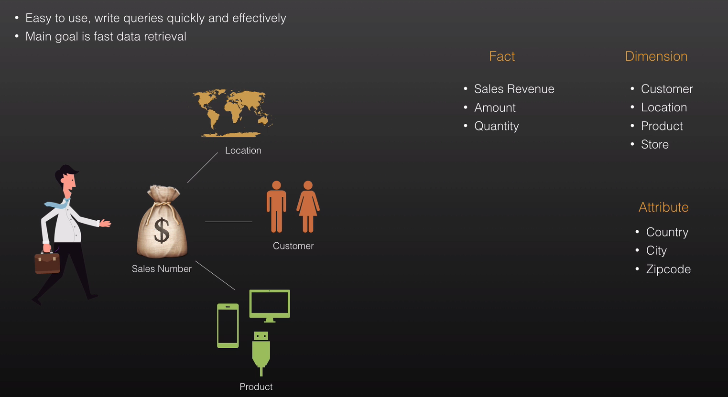

**Fact Table:**

* Include numerical values (Amount, Quantity).
* Includes foreign keys to associated dimension table.
* Generally it has small number of columns but large number of rows.

**Dimension Table:**

* Descriptive characteristic of the fact.
* Joined to fact table via a foreign key
* De-normalized tables.
* Use a surrogate key
* Store the history

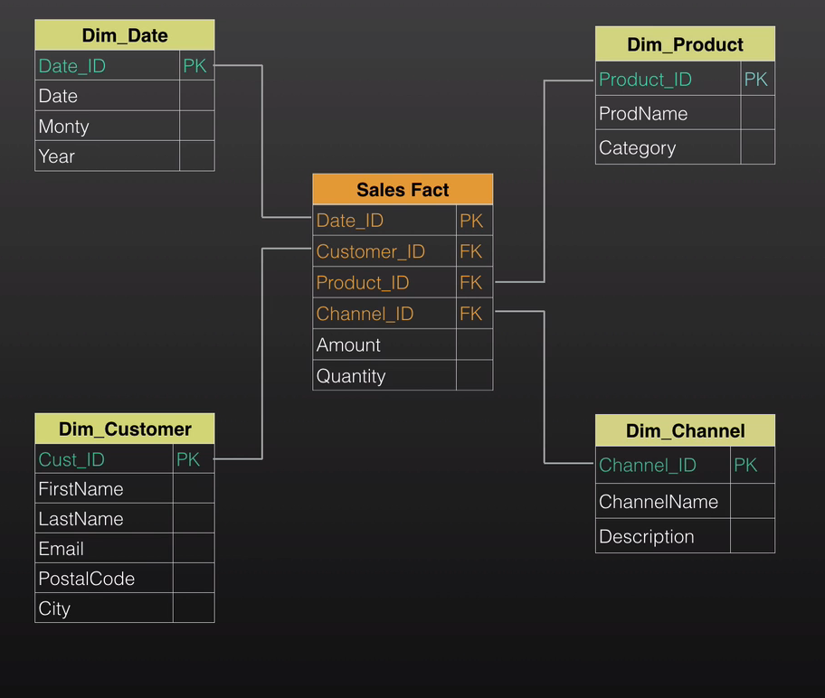

**Importance of Dimension Modeling:**

* Ease of understanding for user end, more focus on business prospective
* Faster database performance.
* Flexible to business change.
* Easy Reporting
* Historical Data, help to get detail of history.

**Dimensional & 3NF:**

|  |  |  |
| --- | --- | --- |
|  | **Dimensional Model** | **Normal Form Model** |
| **Used In** | OLAP | OLTP |
| **Structure** | De-normalized | Normalized |
| **Operation** | Fast read operation | Fast write Operation(insert,update,delete) |
| **Query Performance** | High performance | Lower performance |
| **Business Usage** | Easy | Difficult |

**Start Schema & Snowflake Schema:**

Star Schema:

* Dimension tables do not join each other
* Dimension tables de-normalized
* Fact table include key and measures

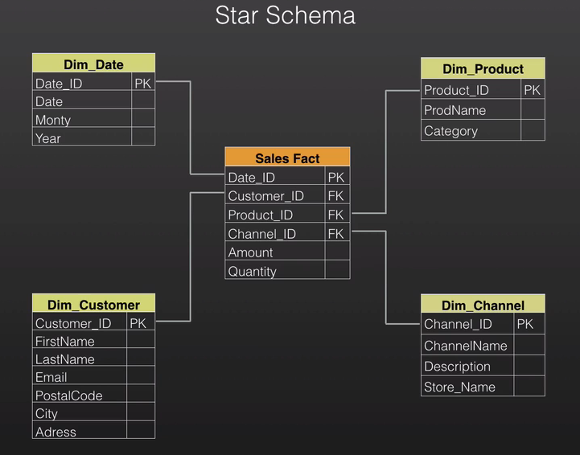

**Snowflake Schema:**

* This is an extension of start schema.
* Uses smaller disk space.
* Dimension tables less de-normalized.
* Reduce query performance.

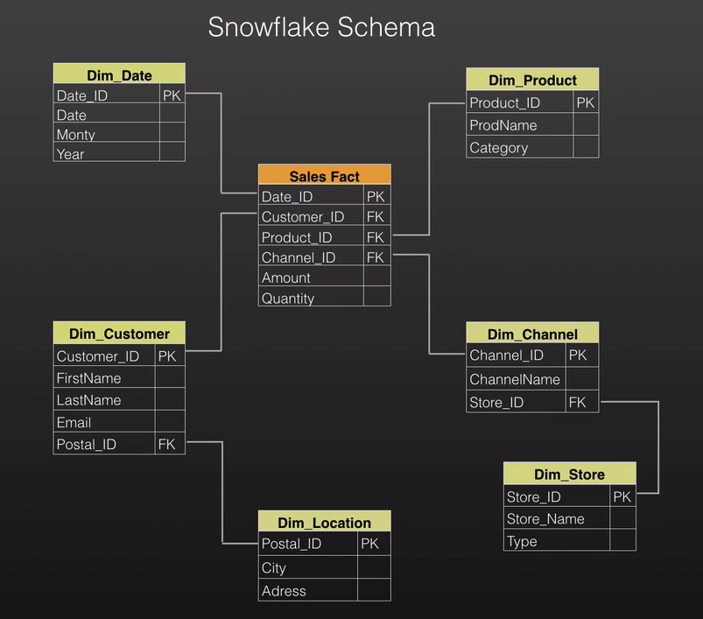

**Start Schema VS Snowflake Schema:**

|  |  |  |
| --- | --- | --- |
|  | **Star Schema** | **Snowflake Schema** |
| **Normalization** | De-normalized | De-normalized + Normalized |
| **Maintenance** | More Redundancy | Less Redundancy |
| **Query** | Simple Queries due to De-normalized | Complex Queries due to Normalized |
| **Join** | Less Join | More Join |
| **Performance** | Faster Performance | Relatively Slower Performance |

**Slowly Changing Dimension (SCD):**

Slowly changing dimensions are used to capture changing data within the dimension over time.

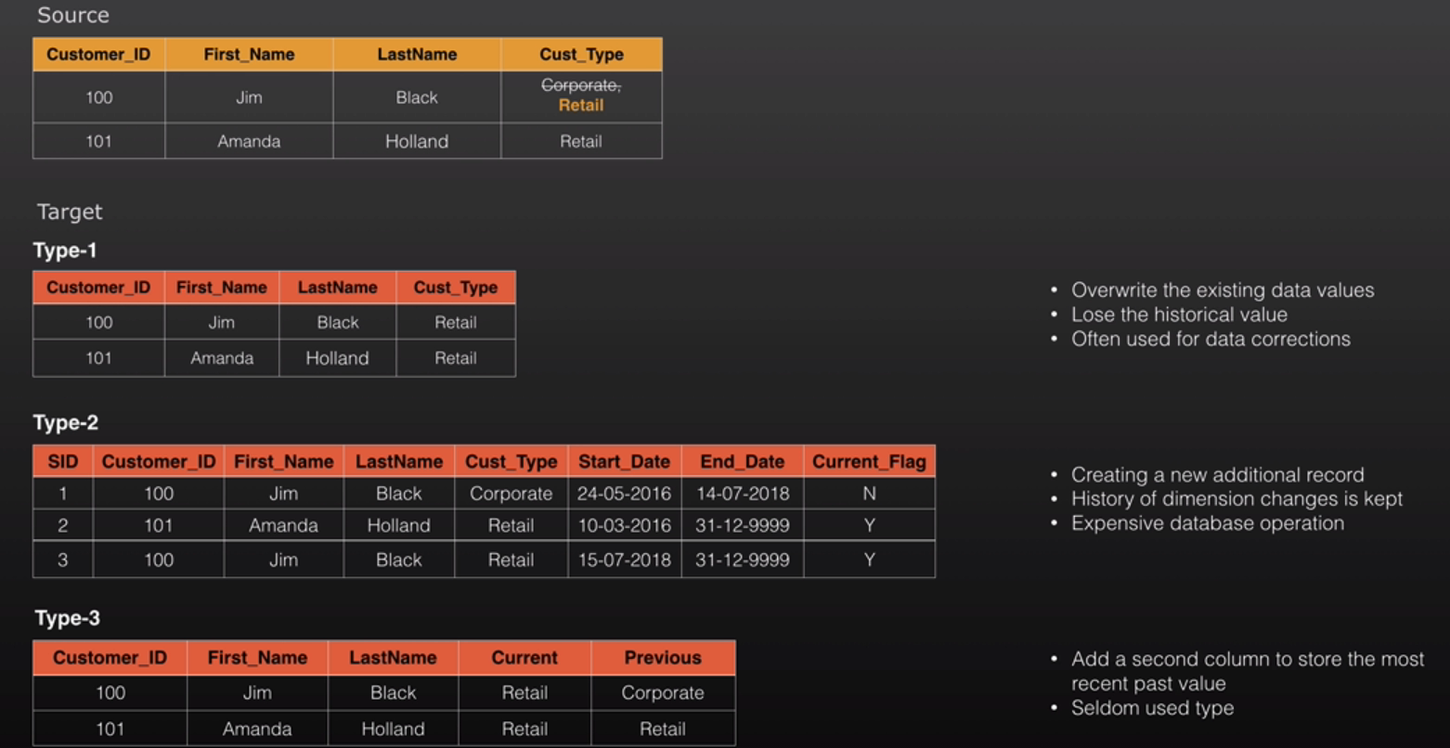

Let’s suppose, IN source system customer type change from **Corporate to Retail,**So, there could be three type of Target table,

**Type-1:**

* Overwrite the existing data values.
* Lose the historical values
* Often used for data correction

**Type-2:**

* Create a new additional records
* History of dimension changes is kept
* Expensive data operation, therefor not recommended for the table that changes frequently
* Here, **SID** is used as **Surrogate** key to uniquely identify the records but it does not have any business meaning.
* **Surrogate** key is sequentially generated unique number
* Eliminate source system dependency
* Increase performance with using suitable data type on joins.
* Mostly Operational system uses Business Key(like customerId, productId etc)
* DWH uses **Surrogate** key.

**Type-3:**

* Add the second column to store the most recent past value
* Seldom use type

**Conformed Dimensions:**

* Shared by many facts tables
* Same meaning with every fact table join
* Reduce development cost by reusing dimensions
* Same Structure and attributes in every model
* Allow Various fact tables to be used in the same query

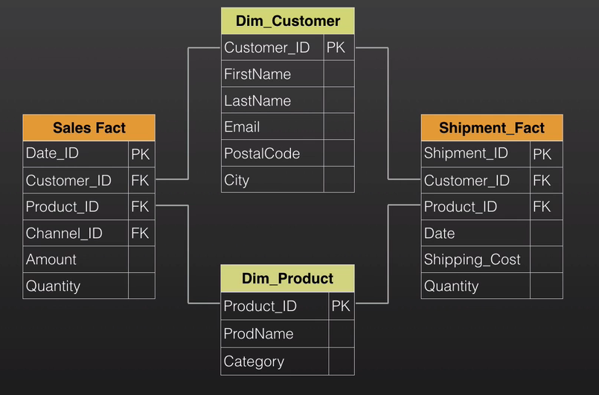

**Data Vault:**

**Data Vault 1.0:**

* Focused on Data Vault Modeling

**Data Vault 2.0:**

* Performance and scalability
* Scrum and Agile Best practice
* NoSQL system and Big data system

A detail oriented, historical tracking and uniquely linked set of normalized tables that support one or more functional areas of business, It is a hybrid approach encompassing the best of breed between 3NF and Star Schemas. The design is flexible, scalable, consistent and adaptable to the needs of the enterprise. Data vault is mainly composed of **HUB, Satellite and Link.**

**HUB:** represent the business key that are uniquely identify which has very low tendency to change.

**Link:** Link represent the relationship between the **HUB**.

**Satellite**: include the descriptive attribute of **HUB** and **Links** tables, and it consist the data that tends to change over time.

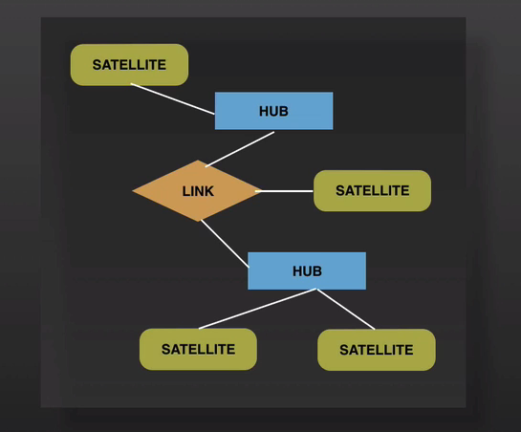

**Benefits:**

* Flexible and adaptable to meet the changing needs.
* Support incremental delivery.
* Agile Approach aligned with incremental delivery.
* Change does not impact existing structure.
* Integration with Big data technologies
* Hash Keys in data Vault2.0 support parallelization.
* Auditability
* Possible to Automate

**Automation Tools:**

* Wherespace
* Quippu
* BI Ready
* AnalytiX DS
* Rapid Ace

**Drawbacks:**

* More tables requires lot of join’s
* Impractical for direct querying
* Load Data Marts can be rather complex

**Use case:**

If you have small to medium size analytics requirement with data engineer and architects, designer for the data source for few system than Data vault may not suitable for needs. Dimensional Modeling would be fine for that. If your Data is strait forward, then Data vault may not suitable as it requires more storage.

**Data Vault Basics:**

**HUB:** Unique list of business keys

**Link:** Unique list of (n to n) relationships between business keys.

**Satellite:** Contain descriptive historical data associated with Hubs and Links.

**Business Key:**

* Natural Keys uniquely identify each entity(Customer Num, Product Code)
* Have meaning to business independent from the operational system
* Not equal to PK all the time

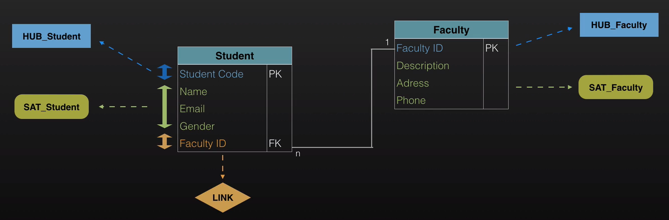

**HUB:**

|  |
| --- |
| **HUB** |
| H_Hash_KEY PK |
| Business Key(BK) |
| Load Date (LOAD_DTS) |
| Record Source (REC_SRC) |

**Primary Key(H_Hash_KEY):**

* Hash based unique identifier (Hashed value of Business Key)
* Surrogate Keys(Sequence number) replaced by Hash-based primary keys in DV2.0

**Business Key:**

* BK can be natural or composite key

**Load Date:**

* Generally a date and time when the Business key was first recorded.
* This field is created the first time and never dropped or updated.

**Record Source:**

* Which source system the BK came from.

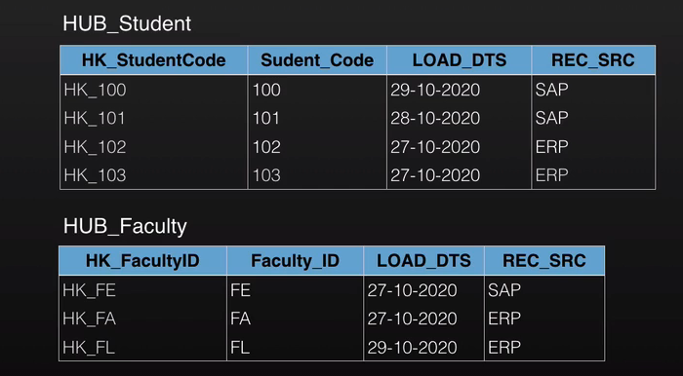

**Rules of HUB:**

* The Hub entity must NEVER contain foreign keys.
* Hubs must stand alone ( be a parent to all other tables), they must never be children.
* Should have at least **1** **satellite.**
* Direct **HUB-to-HUB** relationship is not allowed.
* HUB **BK** and **PK** never Change.

**LINK:**

|  |
| --- |
| **LInk** |
| L_Hash_KEY (HK) PK |
| HUB1_HK FK1 |
| HUB2_HK FK2 |
| Load Date (LOAD_DTS) |
| Record Source (REC_SRC) |
| Dependent Child Key(Optional) |

**Primary Key(L_Hash_Key):**

* Hash based unique identifier (New Hash value based on business keys from Linked HUBS).

**Hash key of HUBS(HUB1_HK & HUB2_HK):**

* Hash keys of the linked Hub tables.

**Load Date:**

* Generally a date and time when the Business key was first recorded.

**Record Source:**

* Which source system the BK came from.

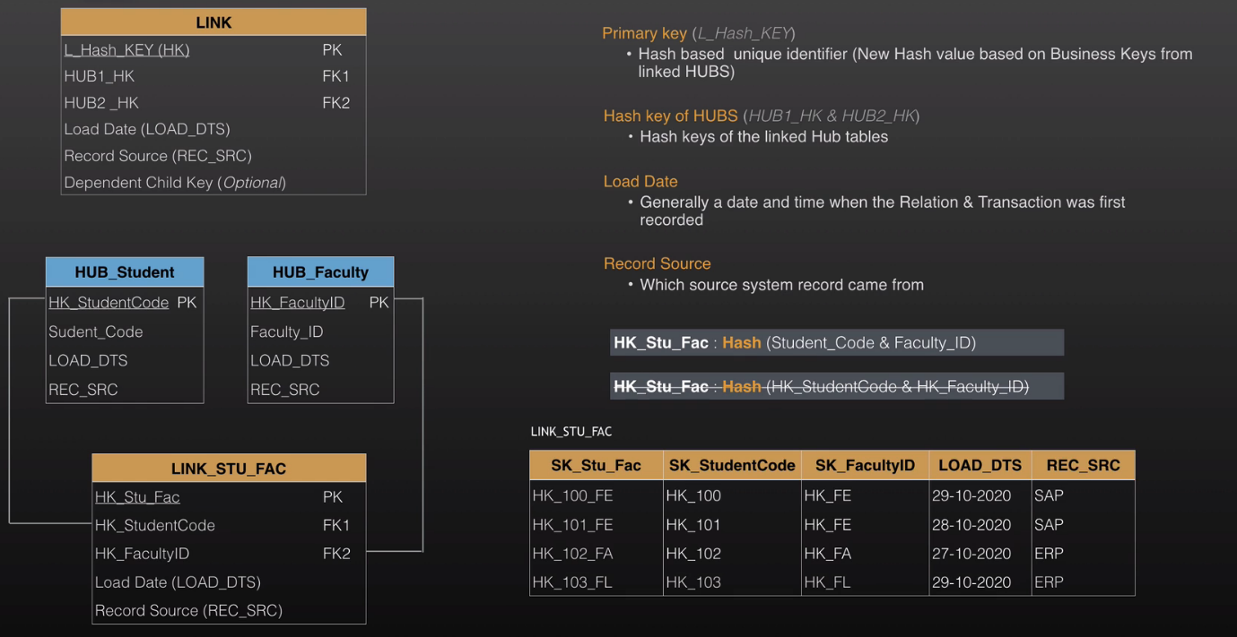

**Benefits:**

* Many-to-Many relationships provide the following benefits.
* Flexibility
* Granularity
* Scalability
* Dynamic Adaptability

**Links Table Rules:**

* The Link entity must NEVER contain natural business keys, or begin and end dates.
* Link hub tables, link tables do not contain descriptive information
* Links exist at the lowest level granularity
* Links are always M-M
* Satellites are optional for Links (Excepts for hierarchical links)
* Links can be connected other links.

**SATELLITE:**

|  |
| --- |
| **SATELLITE** |
| Hash_KEY (HK) PK, FK |
| Load Date (LOAD_DTS) PK |
| Attributes |
| Hash Diff (Optional) |
| Record Source (REC_SRC) |

**Primary Key:**

* Hash Key from connected HUB or Link + Load Date.

**Load Date:**

* Generally a date and time when the data was first recorded in EDW.

**Attributes:**

* Descriptive data like Name, Email, Gender

**Hash Diff:**

* Help to compare a new record to the older ones and identify changes.

**Record Source:**

* Which source system the record came from.

**Satellite Rules:**

* A Satellite can have one and only one parent table.
* The Satellite entity must NEVER contain foreign keys.
* PK : HK + Load Date
* Existing records are never updated or deleted.
* Main goal to store historical data

**Split by:**

* Source- avoid flip-flop effect.
* Rate of change (In order to avoid redundant storage of data).
* Data Types.

**Modeling Steps:**

* Setting Naming Conventions.
* Model the HUBS by identifying business key from source.
* Model The LINKS
* Model the SATELLITES.
* Add Standalone Objects *
* Add Performance Table *
* Design Information Mart *

**First Data vault design:**

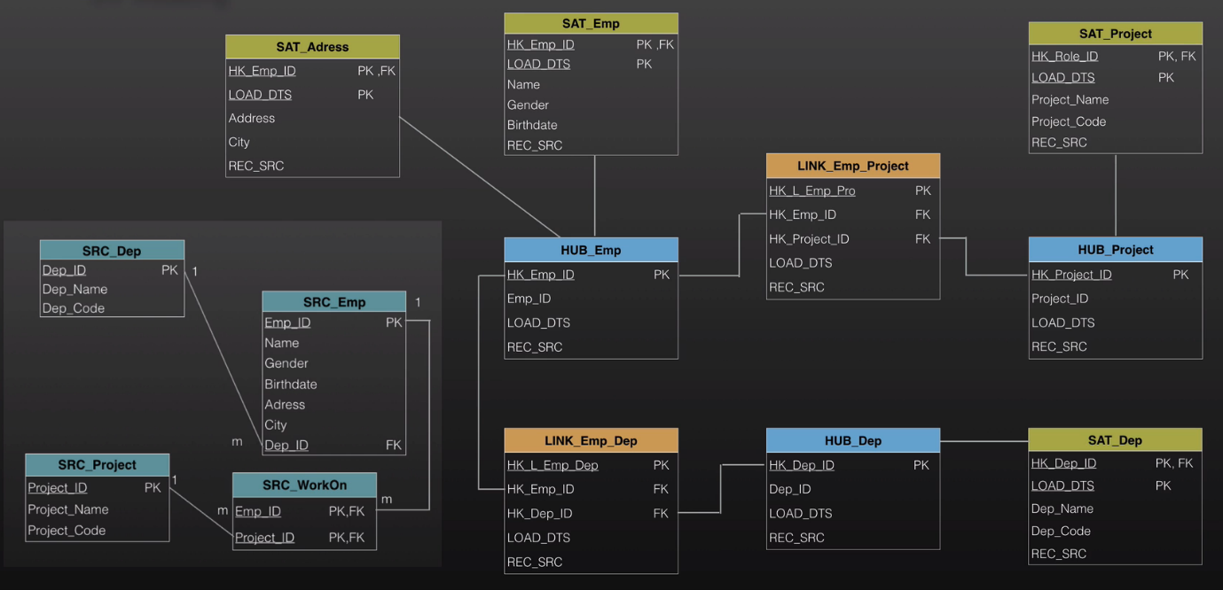

**Link Details:**

**Relationships/Association:**

* Standard Link(Foreign Key & Primary Key Relationship)

**Hierarchies and Redefinitions:**

* Hierarchical relationships are modelled by HAL(Hierarchical Link)

**Transactions and events:**

* Non Historized Links(Different modelling discussion Hub Or Link)
* Sales order or Sensors data

|  |
| --- |
| Link |
| Link_HASH_Key |
| HK_HUB1 |
| HK_HUB2 |
| LOAD_DTS |
| REC_SRC |

* Unique relationship.
* Does not include descriptive data.
* Relationship in past, present, and future.
* Link does not contain **end_data or start_date.**

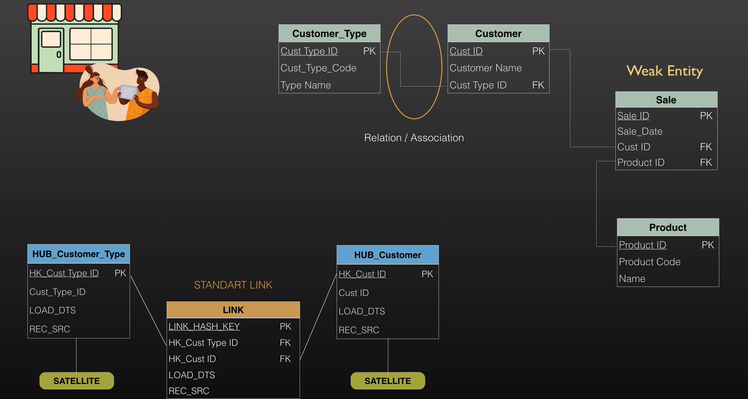

Note: Sale occur when customer by product Weak entity (Sales) will discuss later.

**Hub Transactional Modeling:**

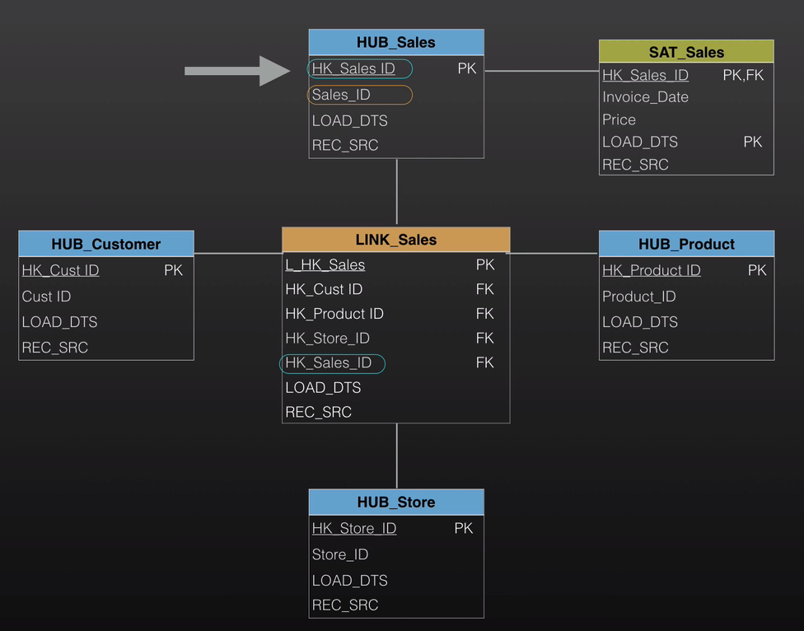

**Link to Link Demoralization:**

Link to link de-normalization not recommended, it should not depend on reference key,

Make link independent.

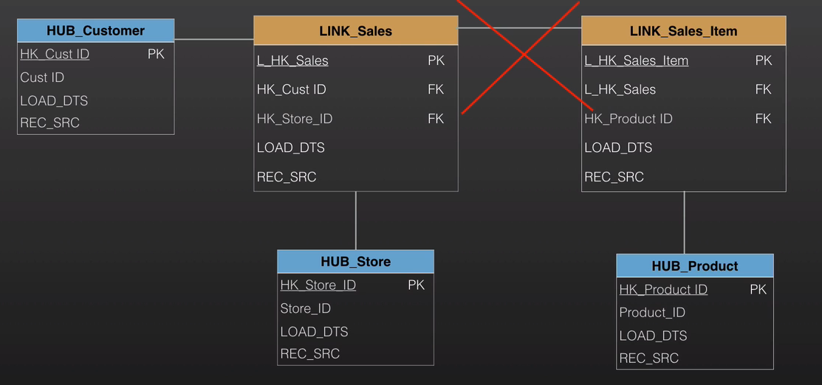

**Granularity Change:**

Check the different scanerio.

**Satellite Details:**

|  |
| --- |
| **Satellite** |
| **Hash_key(HK) PK,FK** |
| **Load Date (LLOAD_DTS) PK** |
| **Attributes** |
| **Hash Diff (Optional)** |
| **Load End Date (Optional)** |
| **Record Source (REC_SRC)** |

* **Primary Key:**  Hash Key from connected Hub or Link + Load date
* **Load Date:** Generally a date and time when the data was first recorded in EDW
* **Attributes:** Descriptive data like Name, Email, and Gender.
* **Hash Diff:** Helps to compare a new record to the older ones and identify changes.
* **Record Source:** Which source system the record came from.
* **Load End Date:** Invalid the date when the satellite entry became invalid.

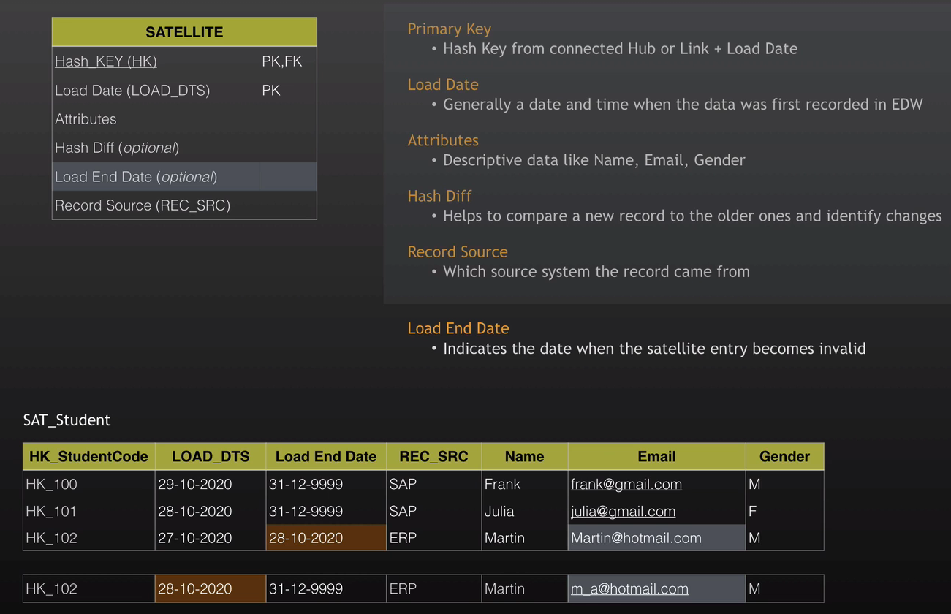

**Change Tracking & Effectivity and Standard Link Satellite:**

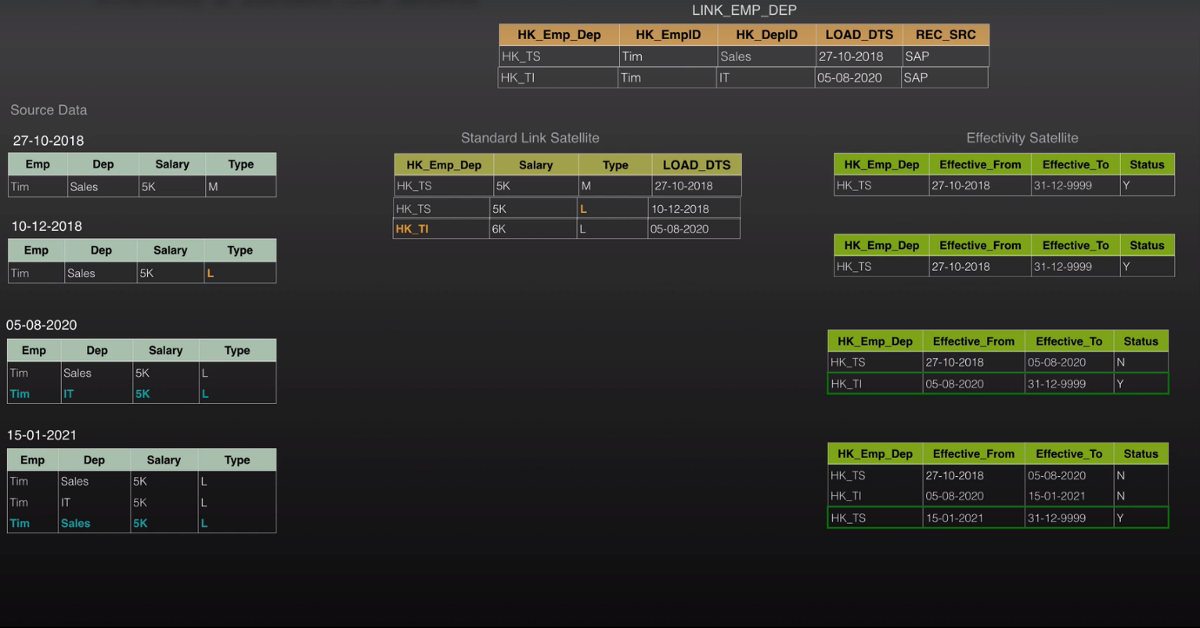

**Data Vault Layer:**

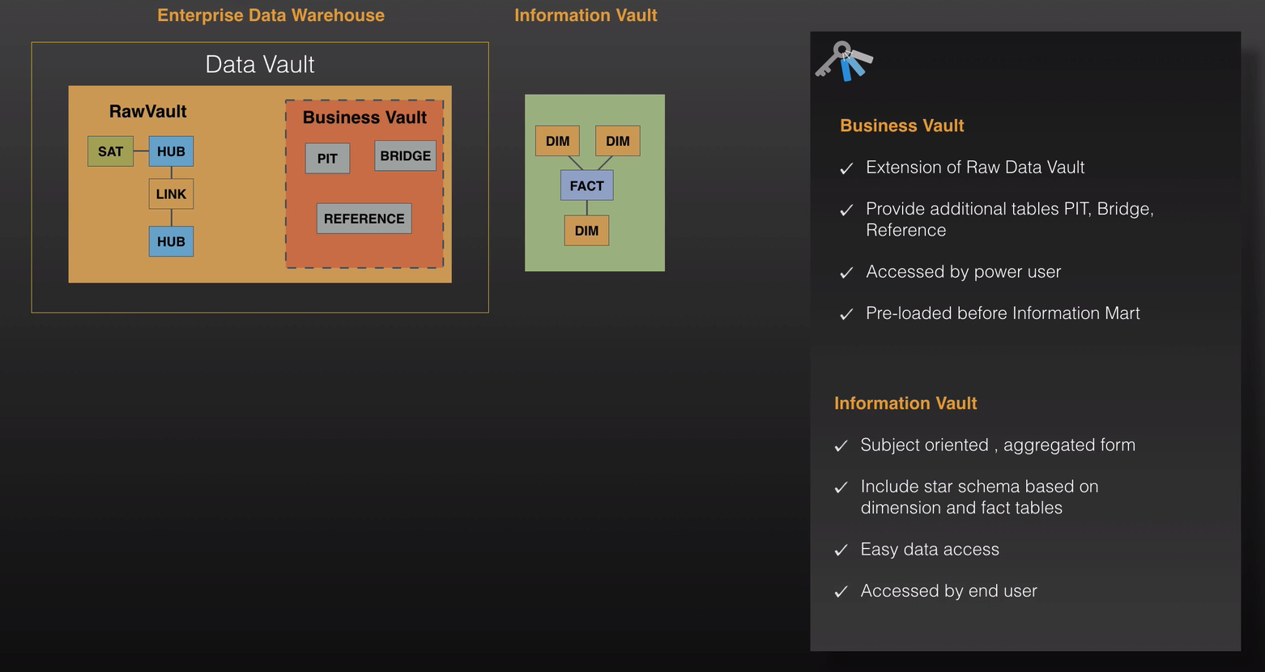

**Business Vault:**

**Point in Time:**

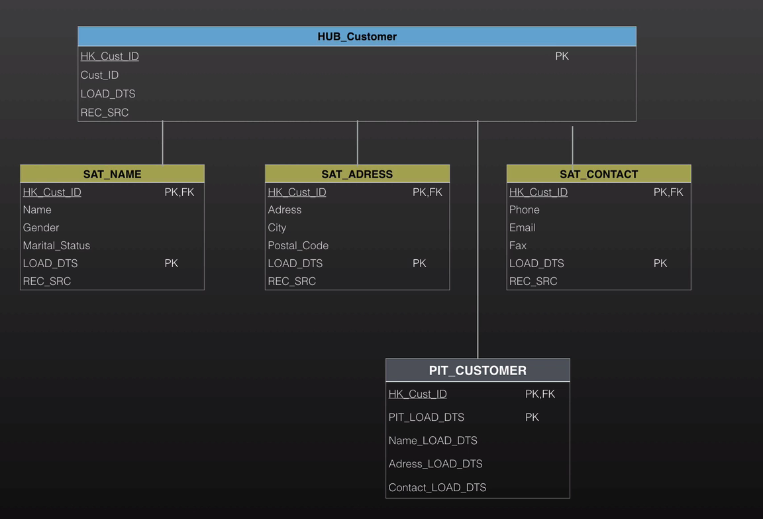

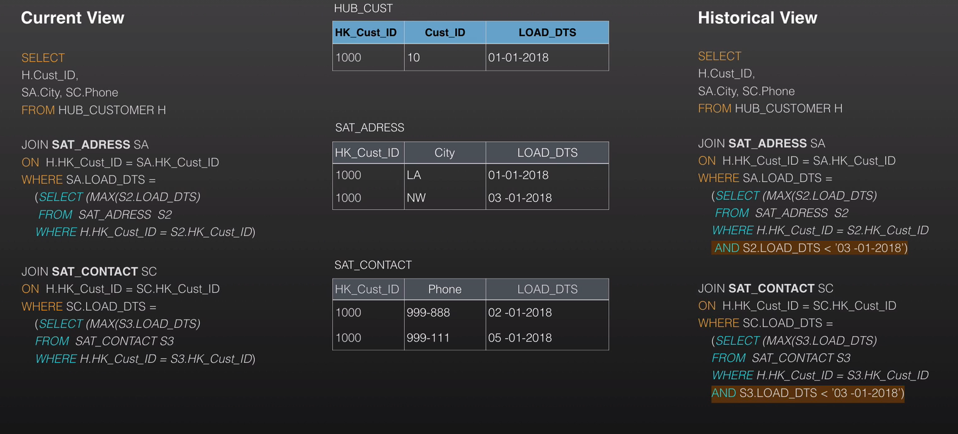

**Using PIT_customer:**

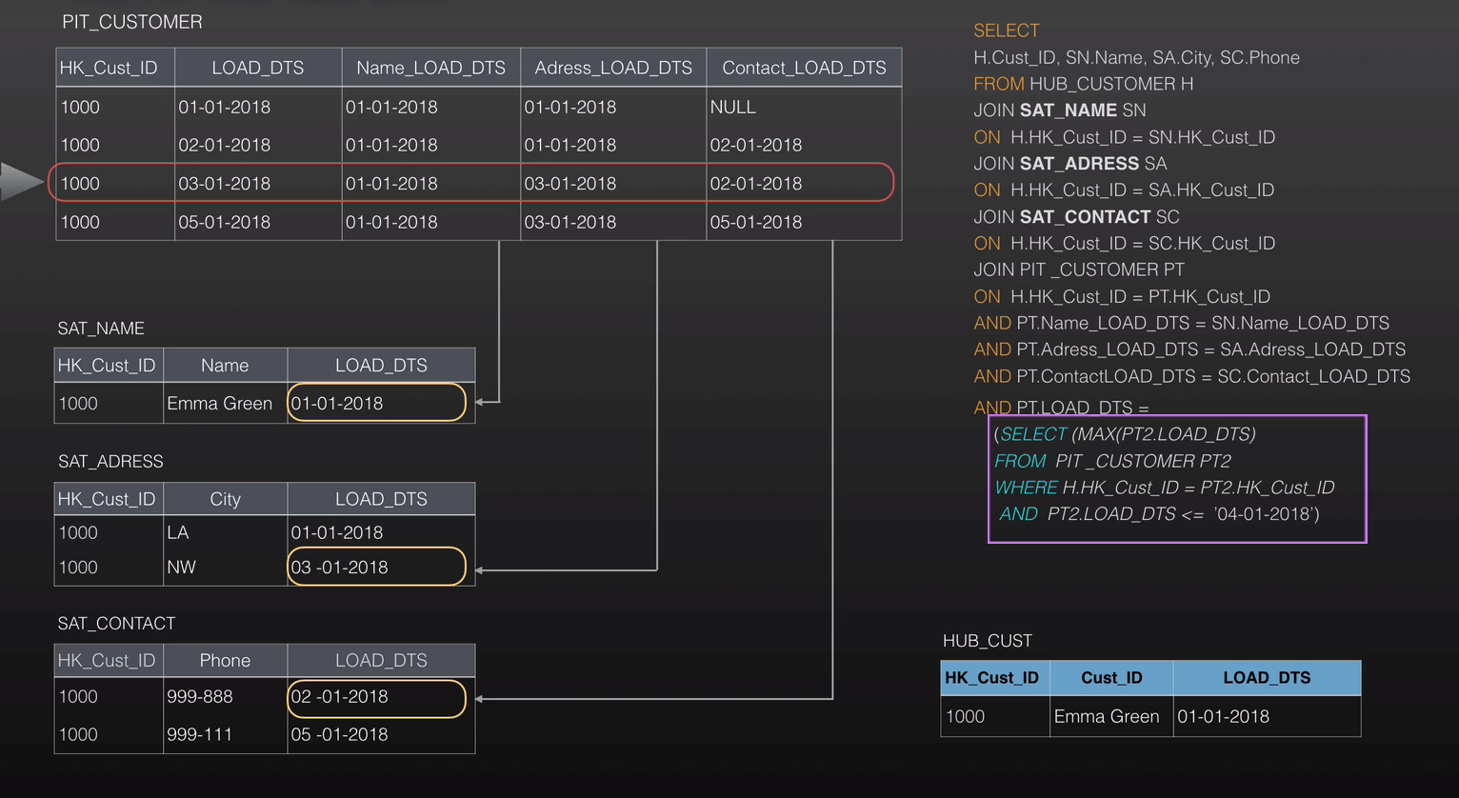

**Bridge Table:**

Bridge table is used to reduce number of join , and enhance performance.

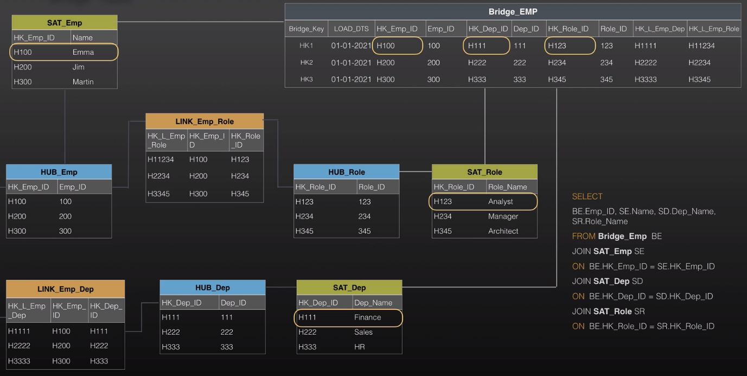

**Information Vault:**

**Dimensional Model in Data Vault:**

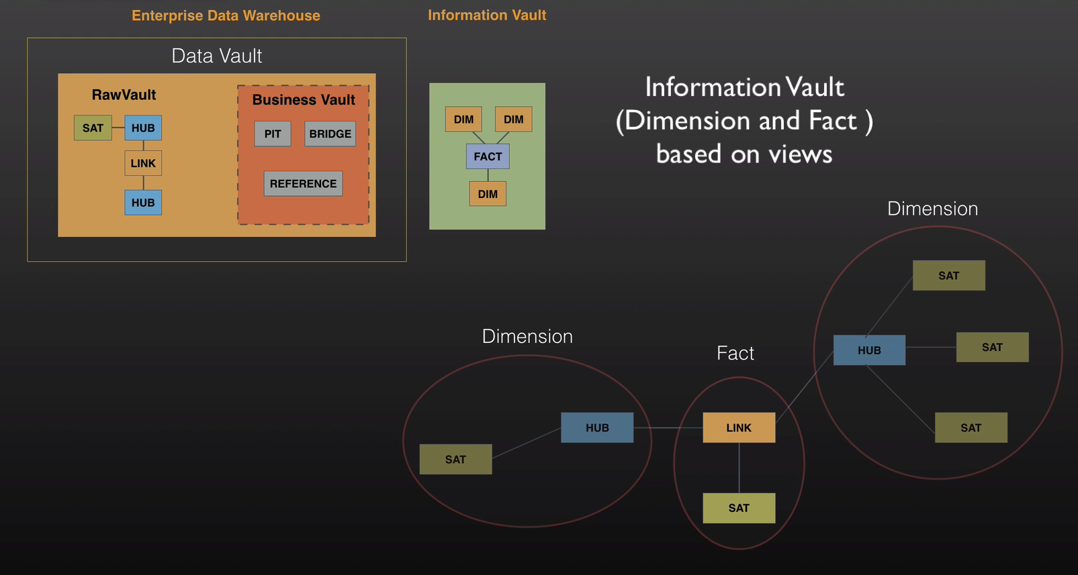

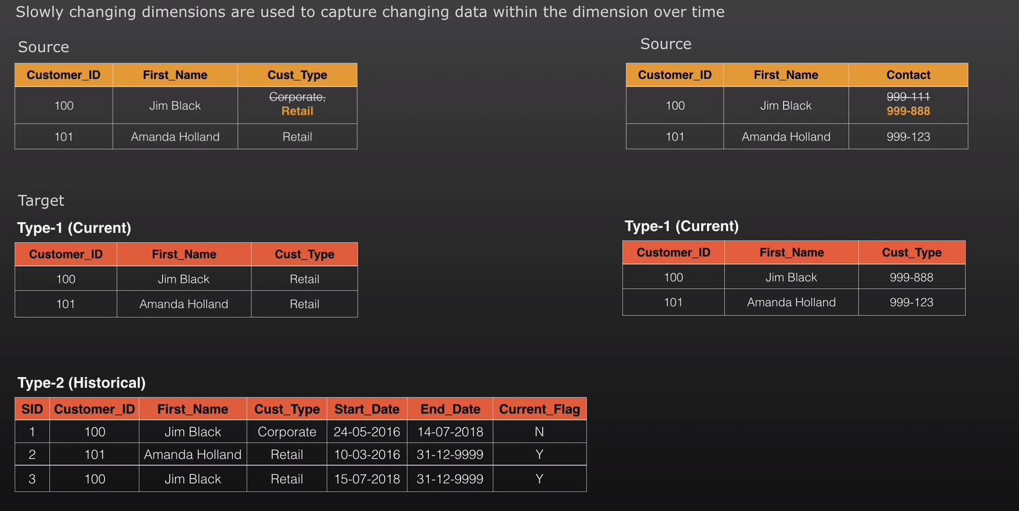

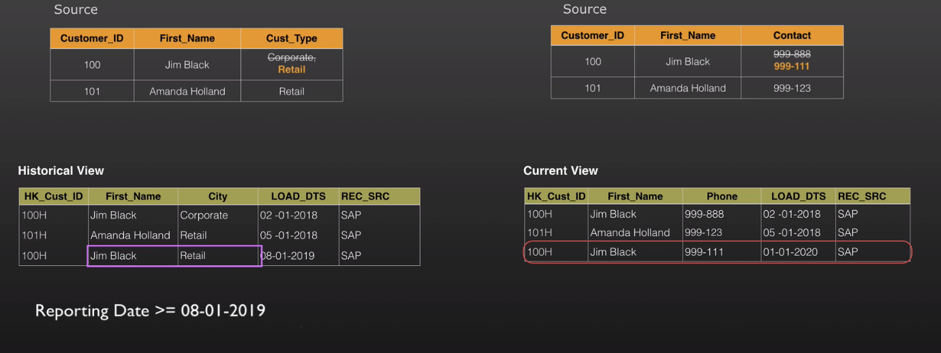

**Note:**  It dependence on how user want to do reporting. So here, need to discuss with Business analysts, and reporting person.

**Type1: Dimension with Single Satellite:**

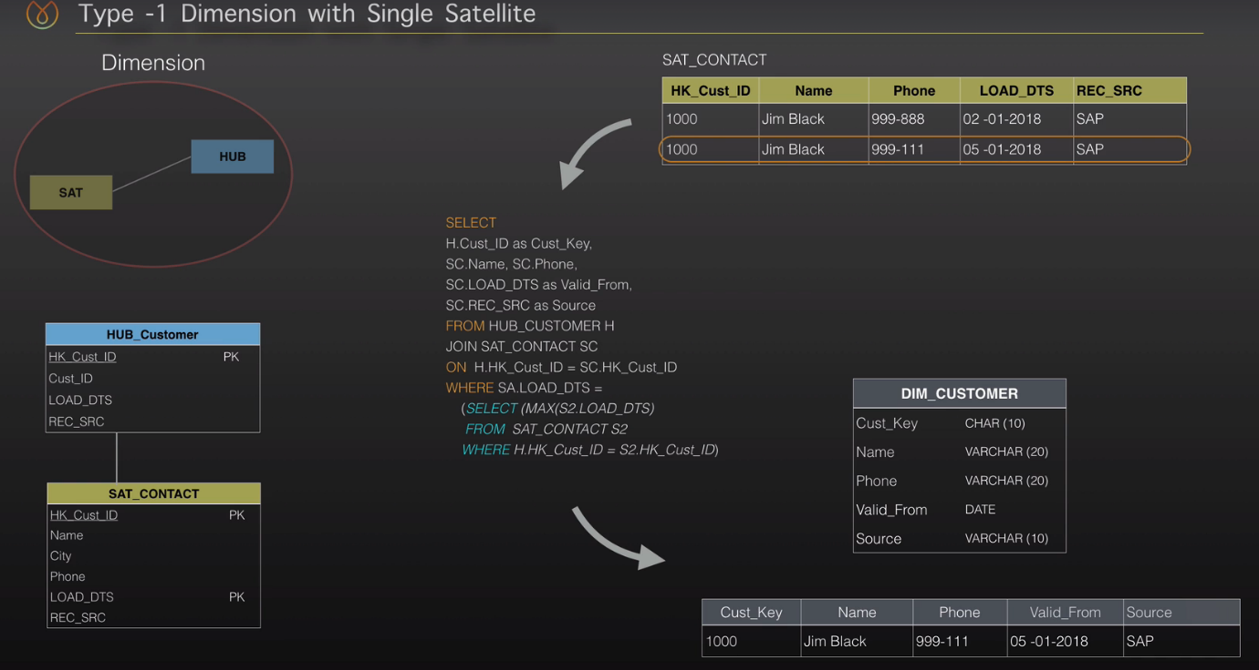

**Type1: Dimension with Multiple Satellite:**

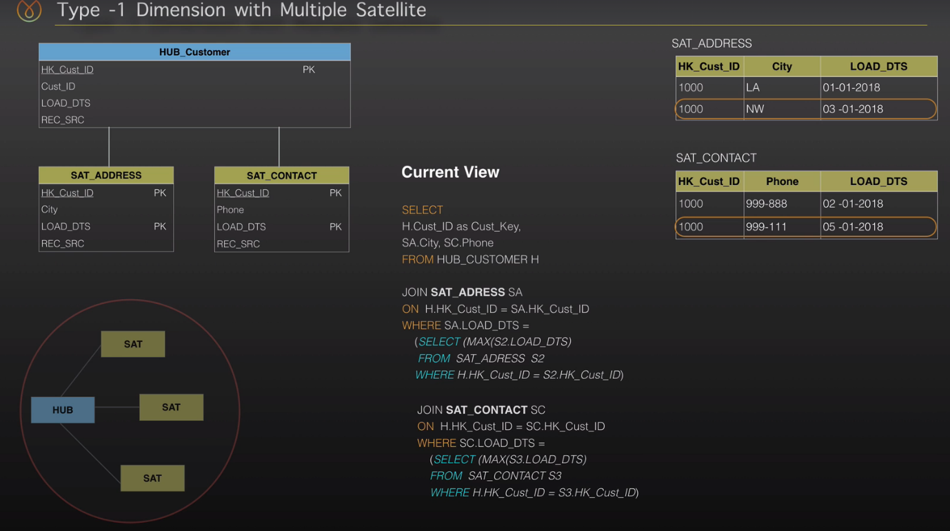

**Note: Point in Time can be used here to increase performance.**

**Type2: Dimension with Single Satellite:**

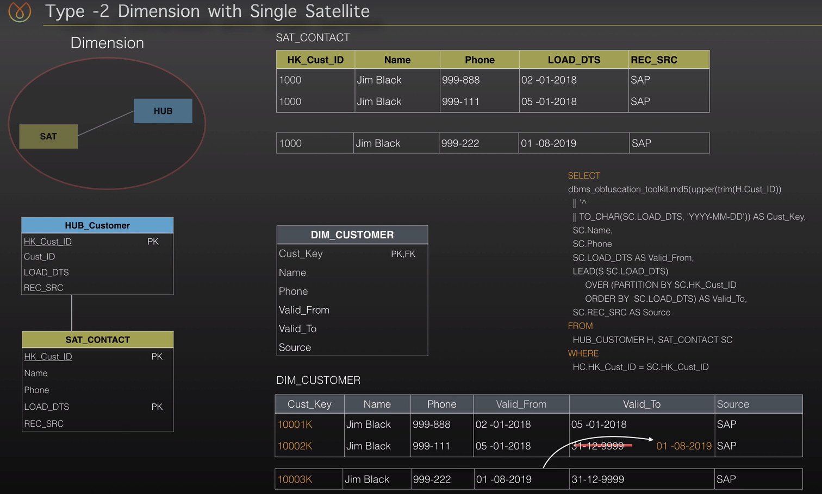

**DWH Load:**

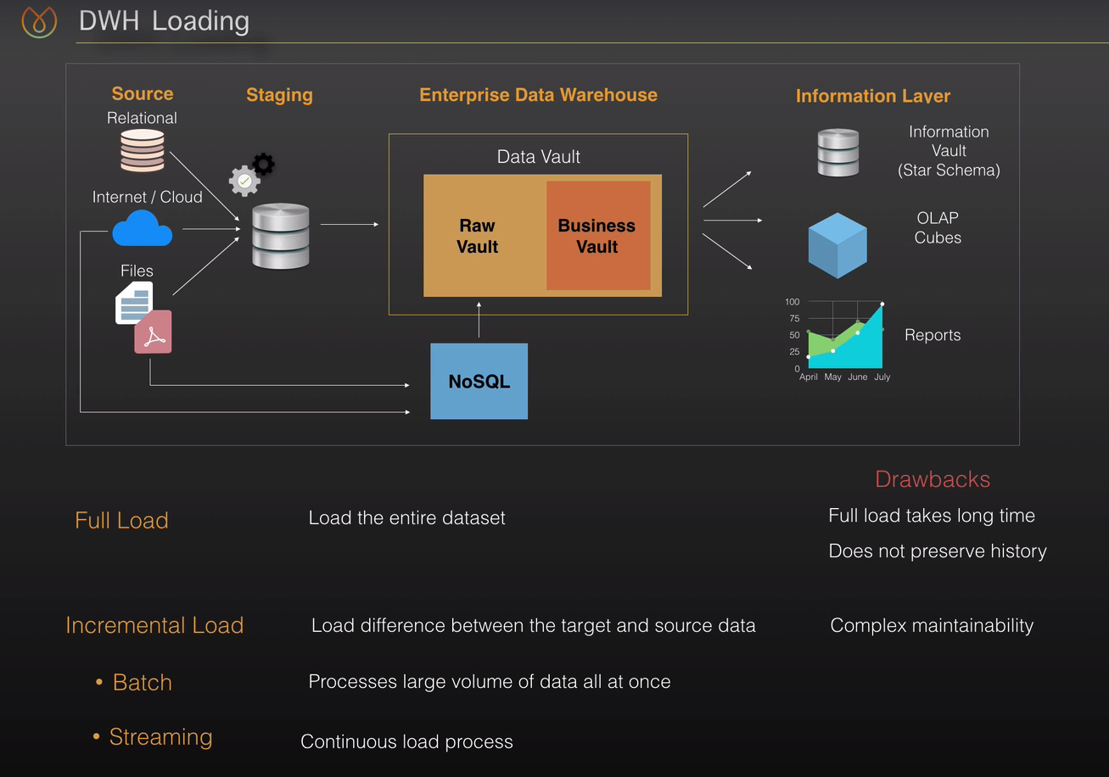

**Data Load Sequence:**

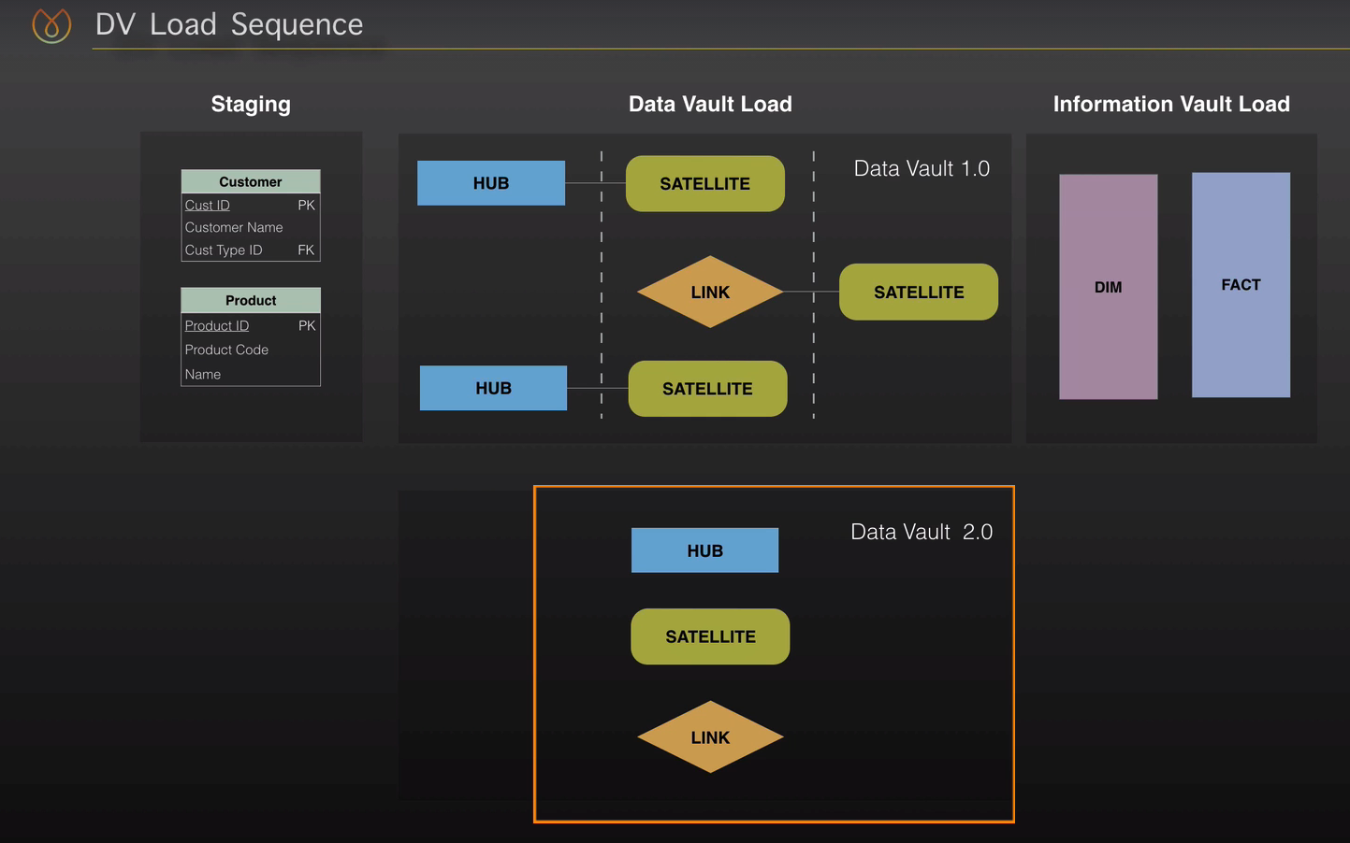

**Note:** In data vault1.0 **,** parallel processing was less as Surrogate key(Integer) has to create and supply to link and satellite.

Data Vault2.0 : provide more parallel processing/loading as it uses Hash key of business column, and Hash key will always same for business column in any table. Like MD(123), will generate always same hash key. The parallel loading is until there is no referential integrity(Parent child relation)

**ETL Load HUB:**

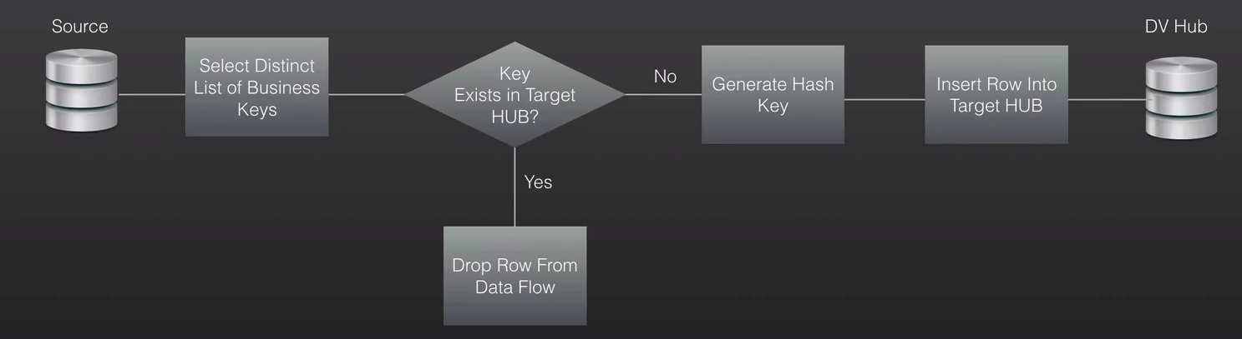

**ETL Load Link:**

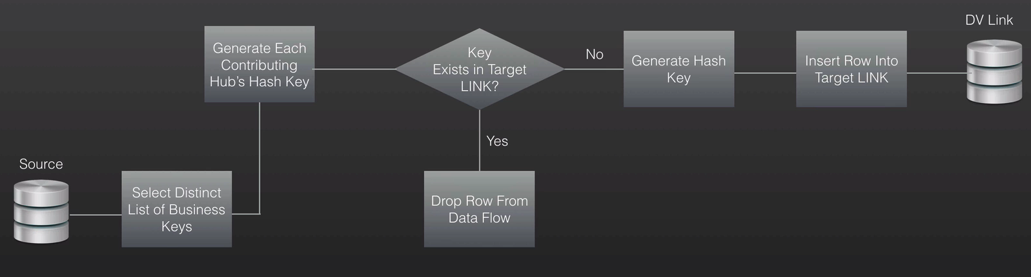

**ETL Load Satellite:**

